**Photodiodes**

**\*\*\***This is a continuance of Optoelectronic Devices (LEDs, Solar panels), so do read this in order to get the difference between Photodiode & Solar cell, Good Luck.

## What is a Photodiode?

A photodiode is a semiconductor pn junction device that converts **light energy into electrical energy**. While LEDs convert electricity into light, photodiodes absorb light to create a measurable current. Their primary purpose is **detecting the brightness** or intensity of light.

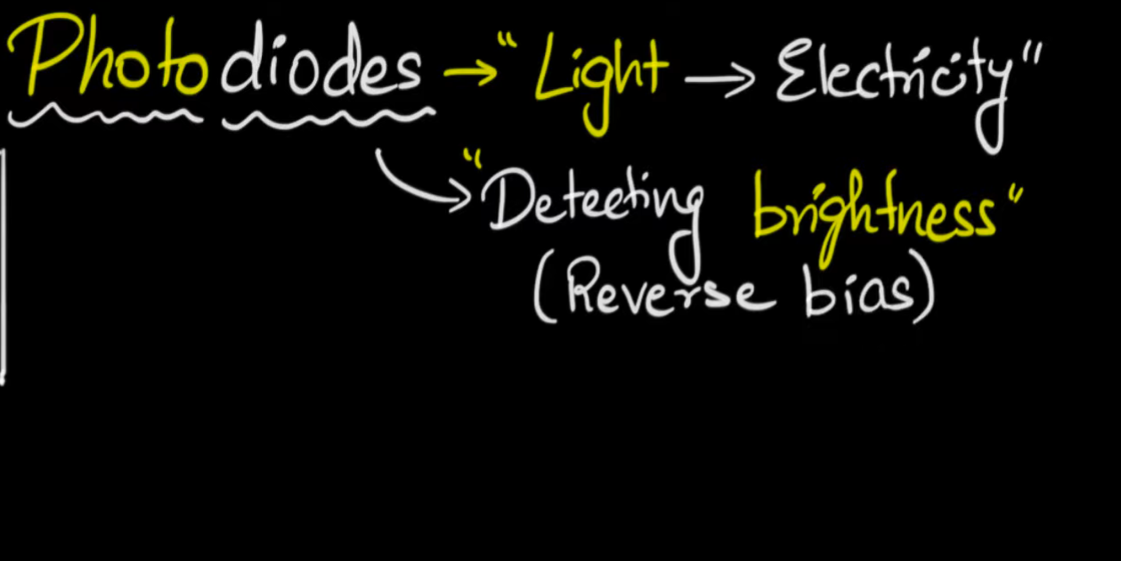

## How it Works: The Importance of Reverse Bias

To function as a sensor, a photodiode must be operated under **reverse bias** (connecting the p-side to the negative terminal and the n-side to the positive terminal).

### 1. The Depletion Region

In reverse bias, the depletion region (the area devoid of free charge carriers) widens. This acts as a barrier that prevents normal current flow, creating a "clean slate" for detecting light.

### 2. Electron-Hole Pair Generation

When photons (light particles) strike the depletion region with energy greater than the semiconductor's **band gap**, they kick electrons from the valence band into the conduction band.

* This creates an **electron-hole pair**.
* The electric field in the depletion region quickly sweeps the electron toward the n-side and the hole toward the p-side.
* This movement generates a **photocurrent**.

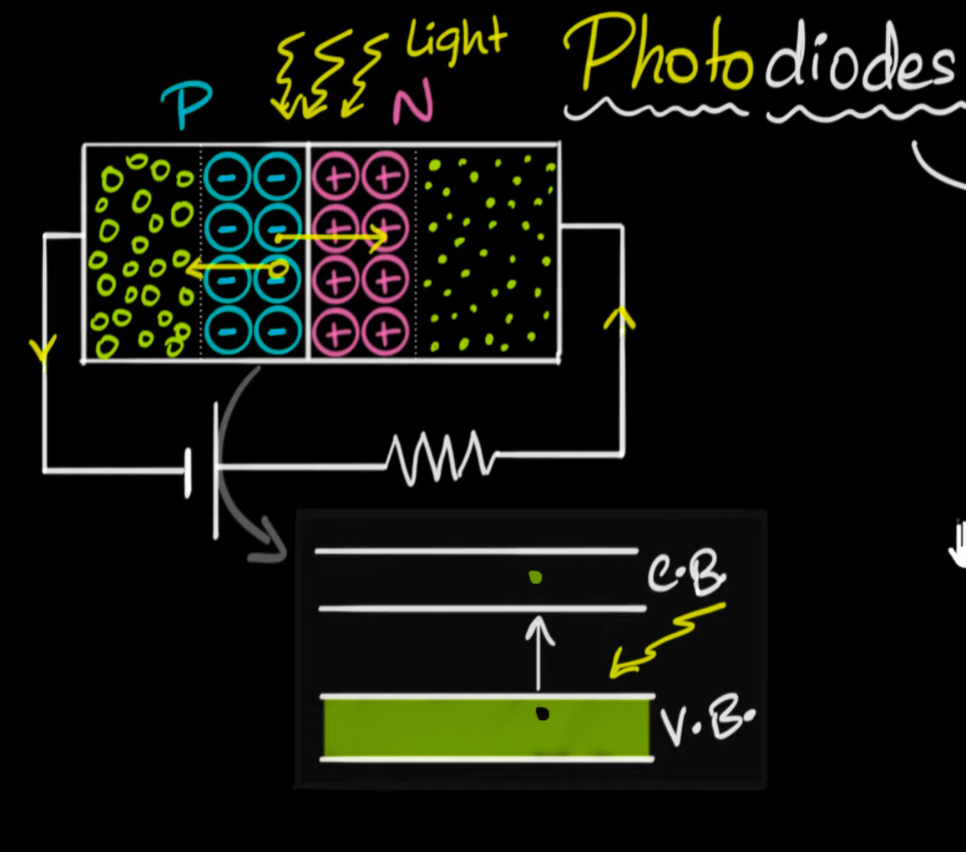

### 3. Why Not Forward Bias?

Forward bias is avoided for two reasons:

* **Recombination:** The depletion region is too narrow in forward bias; most electron-hole pairs would recombine before they could contribute to the current.
* **Noise:** Forward bias naturally allows a large diffusion current, which would drown out the tiny current generated by light.

## V-I Characteristics

The relationship between voltage(V) and current(I) in a photodiode reveals several key traits:

* **Linearity:** The current is almost entirely dependent on the **intensity of light**, not the voltage. Brighter light = more photons = more current.
* **Dark Current:** Even in total darkness, a very small "dark current" exists due to thermal energy creating random electron-hole pairs.

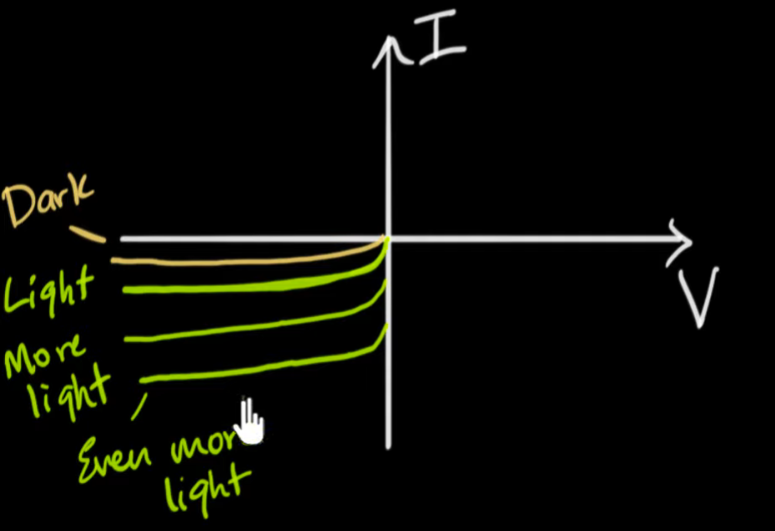

|  |  |
| --- | --- |
| **Feature** | **Description** |
| **Input** | Incident Light (Photons) |
| **Output** | Electric Current |
| **Bias Mode** | Reverse Bias |
| **Key Variable** | Light Intensity |

## Practical Applications

Because photodiodes are sensitive to light levels, they are used in various automation and sensing technologies:

* **Automatic Street Lights:** The system detects when ambient light drops below a threshold to trigger the "on" switch.
* **Currency Counters:** A laser shines on a photodiode; every time a banknote passes through and blocks the beam, the current drops, allowing the machine to count the note.
* **Solar Cells:** While specialized, solar cells are essentially a large-area photodiodes designed to generate power rather than just sense light.